The Geometry of the Chapter House Windows at
York Minster

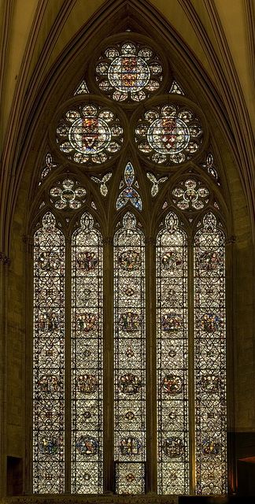

The chapter house windows have been described as “Geometrical [Decorated] at its most handsome.” ¹ The excellence of the tracery derives in no small measure from the three large circles in the head of each window. It is not at all straightforward, if it be possible at all, to fit three equal circles into an existing arch. John Pritchard in 1844 inserted tracery based on the York chapter house windows in the re-opened mediaeval east window of the Lady Chapel at Llandaff ,² but he was constrained to make the upper circle much smaller than the other two. The three circles were probably the starting point of the design, and the arch was fitted round them.

The centres from which the arch arcs were struck must, by symmetry, lie on the common tangents of the upper circle and each of the lower circles. They must also lie on the horizontal line through the springing points of the arch, as otherwise the arch would be segmental or horseshoe.

Naturally the centres of the three circles lie on the vertices of an equilateral triangle. If the sloping sides of this triangle are produced downwards, the horizontal line through the springing points makes with them another equilateral triangle.

Figure 1

C
D
G
B
H
A
If the distance along the common tangent to the centre of the arch arc (AB in Figure 1), is large in relation to the radii of the circles, the springing point of the arch, D, falls within the base of the equilateral triangle CGH. If it is comparatively small, the springing point falls outside the base of the equilateral triangle (Figure 2).

Figure 2

H

A

F

E

B

D

C
G

In the York windows, the springing points are at the lower vertices of the equilateral triangle, so that points C and D in Figure 2 coincide. It is possible to examine the geometry, to see how AB relates to the radii of the circles in order to achieve this coincidence. It is unlikely that we shall recover the thought processes of the designer, but we shall establish the design which he created.

In Figure 2, then, let the circles have unit radius, so AH = AE = FE = 1. We obtain expressions for BC and for BD in terms of AB, and then equate them.

Triangle ABC is a 30º,60º,90º triangle, so AB:BC = √3:2, so BC = AB x (2/√3)

Triangle EAB is right-angled, so by Pythagoras, EB² = AB² + 1².
FEB is a straight line, as the centres of touching circles and their point of contact lie on as straight line, therefore BF = √(AB² + 1) + 1.

BD = BF, so equating BC and BD,

AB x (2/√3) = √(AB² + 1) + 1.
so (2AB - √3)/ √3 = √(AB² + 1)
so, squaring both sides: (4AB² - 4√3AB + 3)/3 = AB² + 1
so 4AB² - 4√3AB = 3AB²

AB cannot be 0, or there would be no arch,

so dividing by AB,
AB = 4√3.
Since BC = AB x (2/√3),
BC = 4√3 x (2/√3)
= 8
therefore, from triangle ABC, AC = 4,
therefore, since AH = 1, CH = HG = GC = 5.

Figure 3

L

K

J

I

H

G

F

E

D

C

B
A

The tracery recognises this fivefold length, as there are five lights, equally spaced, though the mullions are of two grades. The head of each light consists of arcs of radius 1 unit, struck from points D,E,F,G,H and I, one unit apart (Figure 3), so they contain equilateral triangles.

The tall central lancet has centres A and L (Figure 3), which are also the centres of the arcs of the arch. The radius is 6 units, so the arcs of the tall lancet must necessarily touch the lower circles respectively.

The arcs of the outer lancets are struck from centres D,F,G and I, with radius 2 units, so they also contain equilateral triangles, and the apex of each lancet lies on the circumference of one of the lower circles where it is cut by a side of the main equilateral triangle.

The manner of fitting a circle in the head of these outer lancets is shown.
The arcs of the larger lancet are centred on G and I and have radius 2 units. Arcs of the small lancets are also centred on G and I and have radius 1 unit. The circle therefore must have diameter 1 unit, or radius ½ unit. To locate its centre, set the compasses to 1½ units and strike arcs from G and I to see where they intersect, or from I so that it intersects the centre line.

The rest of the design is decoration, though the nine-foils in the large circles deserve special comment. There is no Euclidean construction for a nonagon, so trial and error may have been used. Any error in the compass setting is multiplied by 9 as the circle is stepped round, so it is a simple matter to achieve sufficient accuracy. More sophisticated division of a circle is shown by the gear wheels in the clocks of Wells and Salisbury.

- Alec Clifton-Taylor, The Cathedrals of England, Thames and Hudson, 1967,1974, p.166
- J H James, A History and Survey of the Cathedral Church Llandaff, W M Lewis, 1929, p.19.

Photograph of York Minster Chapter House CHs3 from www.flickr.com/photos

